5 - WebApi_Handson
Input:
Required code snippet portion –
The JWT Authentication Configuration Snippet –
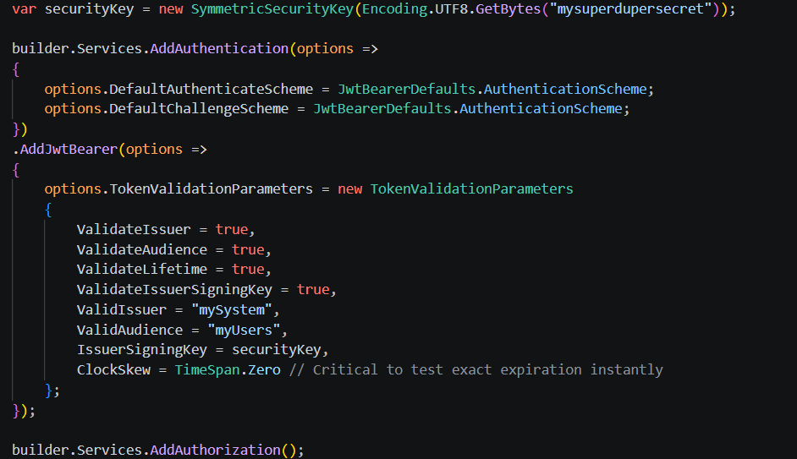
The Token Generation Logic Snippet –
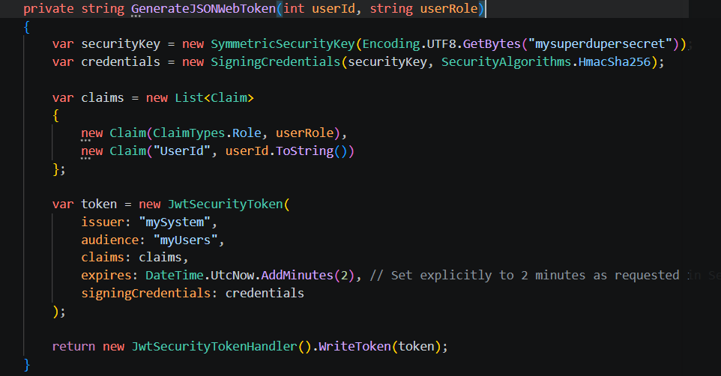

The Enforcing Role Protection Snippet –
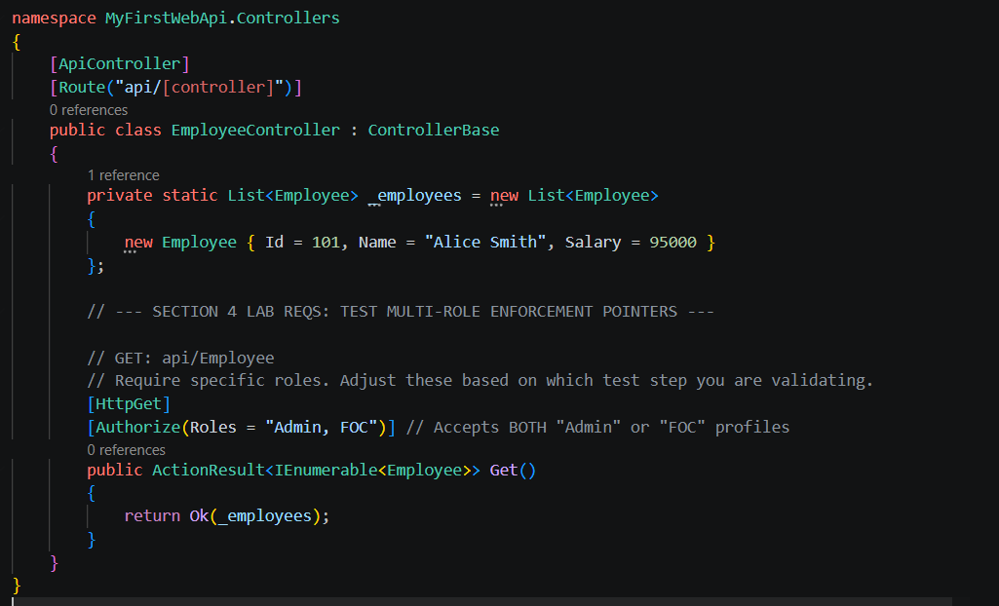
OUTPUT:
Test to Generate a Security Token–
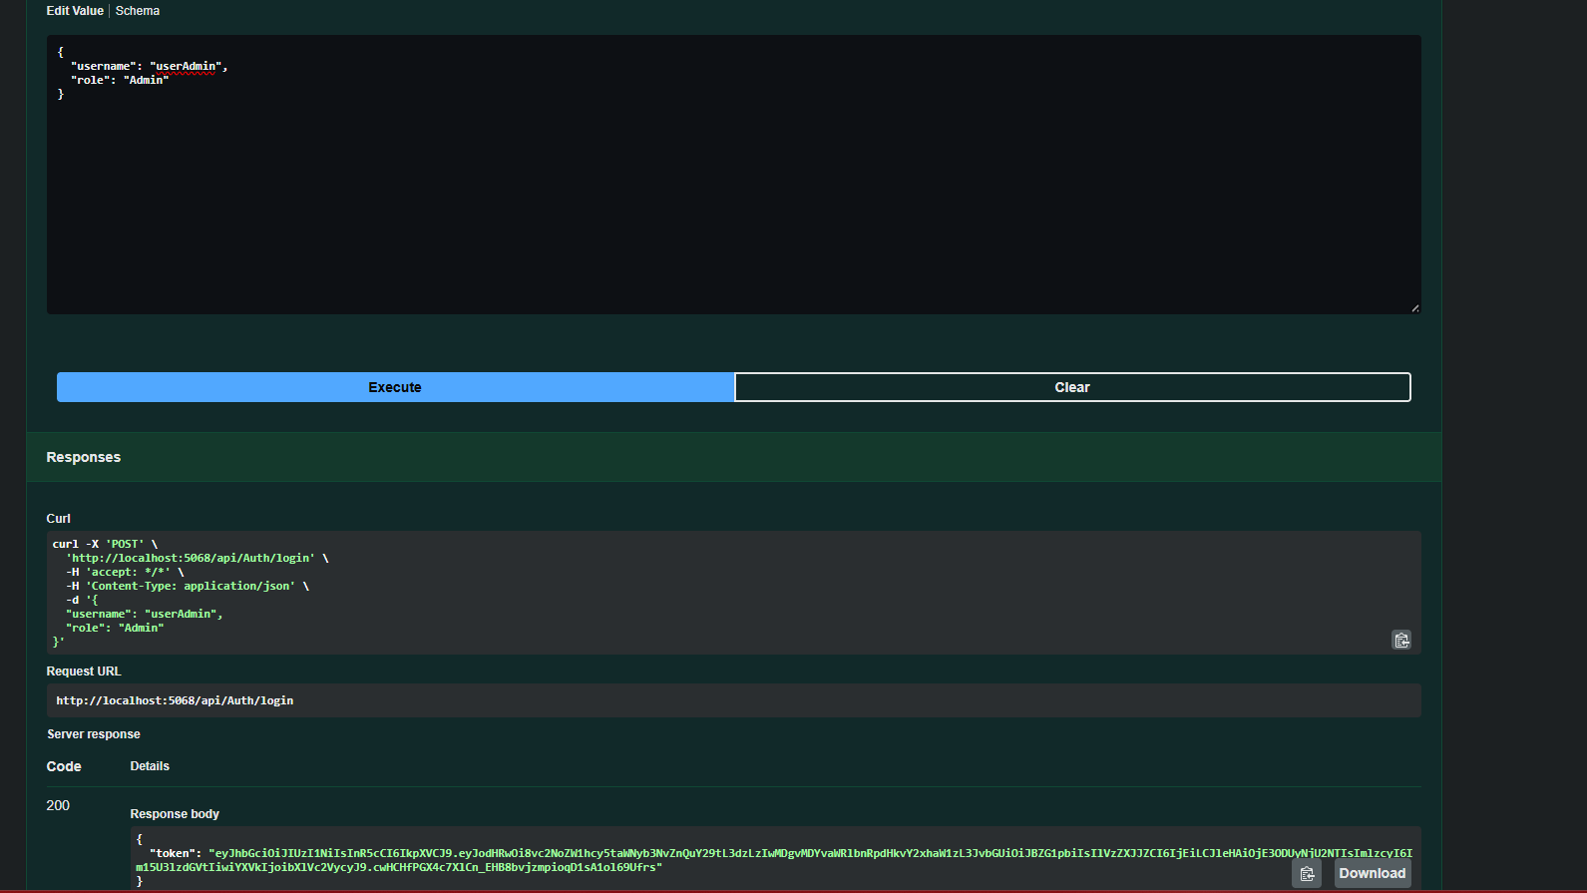

To check the Unauthenticated Access –
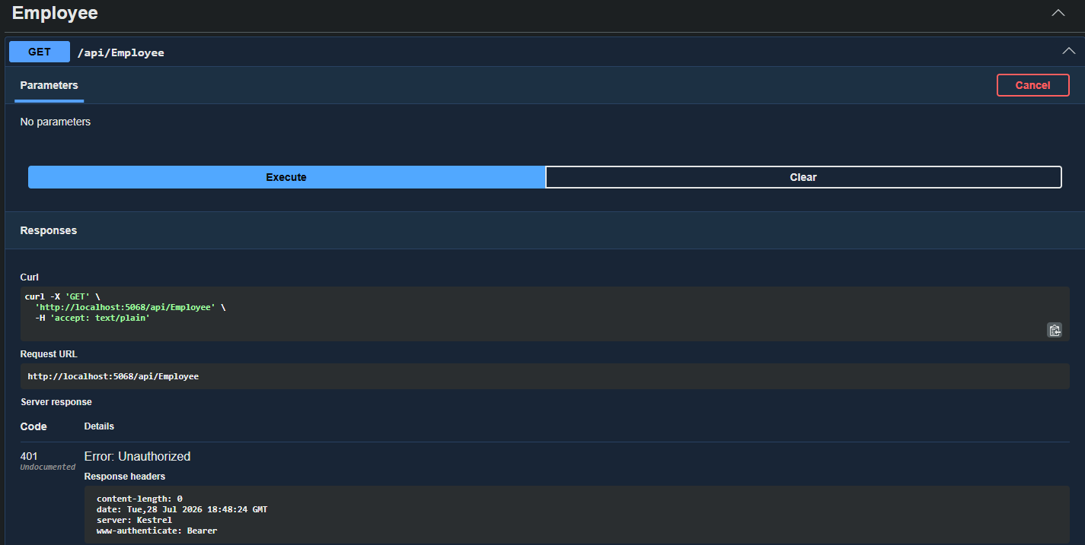
To check with Postman –
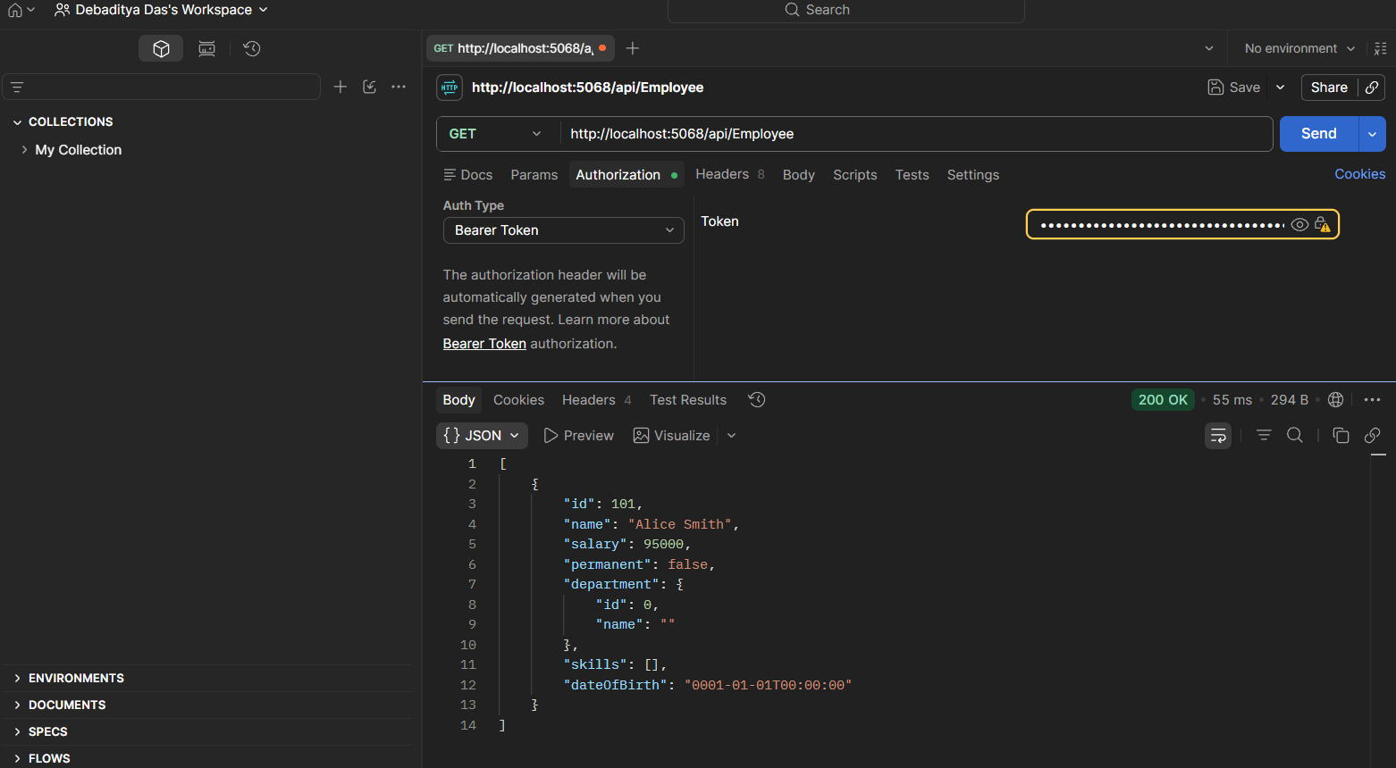

To check Token Expiration after 2 Minutes –
